**PROJECT REPORT**

**SALES PERFORMANCE ANALYSIS**

**BY: ANKITA NIGAM**

**TABLEAU PUBLIC PROFILE:** [SALES PERFORMANCE ANALYSIS | Tableau Public](https://public.tableau.com/app/profile/ankita.nigam3600/viz/SALESPERFORMANCEANALYSIS_16424283954490/Sheet1?publish=yes)

DESCRIPTION

Background

Mike Goodman, the head of Product Management of a retail products company, is responsible for determining which products his company should continue to offer for sale and which products should be discontinued from the company’s product catalog.

Objective

To build a dashboard that will present monthly sales performance by product segment and product category to help client identifying the segments and categories that have met or exceeded their sales targets, as well as those that have not met their sales targets.

Dataset Description

**Sample -Superstore which covers Orders data from 2014 - 2017**;

Within this file you will find the following fields:

|  |  |
| --- | --- |
| **Field** | **Description** |
| Row ID | Observation Index |
| Order ID | Unique Order ID of a product |
| Order Date | Order Placement Date |
| Ship Date | Shipment Date of the placed order |
| Ship mode | Shipment mode of the placed order |
| Customer ID | Unique Customer ID |
| Customer Name | Name of the Customer |
| Segment | Product Segment (i.e.HomeOffice/Corporate/Consumer etc.) |
| Country | Unique Country Name |
| City | Unique City Name |
| State | Unique State Name |
| Postal Code | Area wise Postal code |
| Region | Especially the part of a country |
| Product ID | Unique Id respective to Product |
| Category | Product category |
| Sub-Category | Product Subcategory |
| Product Name | Unique Product Name |
| Sales | Sales Amount |
| Quantity | The amount or number of a material |
| Discount | A deduction from the usual cost of something |
| Profit | Obtain a financial advantage or benefit |

**Sales-Target will cover the target data;**

Within this file you will find the following fields:

|  |  |
| --- | --- |
| **Field** | **Description** |
| Category | Product category |
| No. of Records | Unique Record |
| Order Date | Order Placement Date |
| Sales Target | Targeted Sales to be achieved |
| Segment | Product Segment (i.e.HomeOffice/Corporate/Consumer etc.) |

**TASK PERFORMED IN ANALYSIS**

* **The project required to save datasets sample store and sales target which I have done by clicking on data given on tool bar and selecting on icon of adding new data source .**
* **As per the requirement of the analysis , I have Created a bullet chart with segment and category dimensions and sales measure from sample superstore dataset**
* **The project required to blend the data with saved sample – sales target dataset to bring in the sales target measure .To do this I have dragged sales target measure to details in marks card . By editing reference line I have represented target sales in bullet graph**
* **The project requires to color code the chart to identify categories and segments that are above and below the target sales for which I have created calculated field by going on analysis icon given on tool bar . I have named calculated field with name Above Or Below Sales Target**
* **I Have also added filter on date so as the user can select one, more than one years**

**ANALYSIS BETWEEN ACTUAL SALES AND TARGET SALES REPRESENTED CREATED BULLET CHART :**

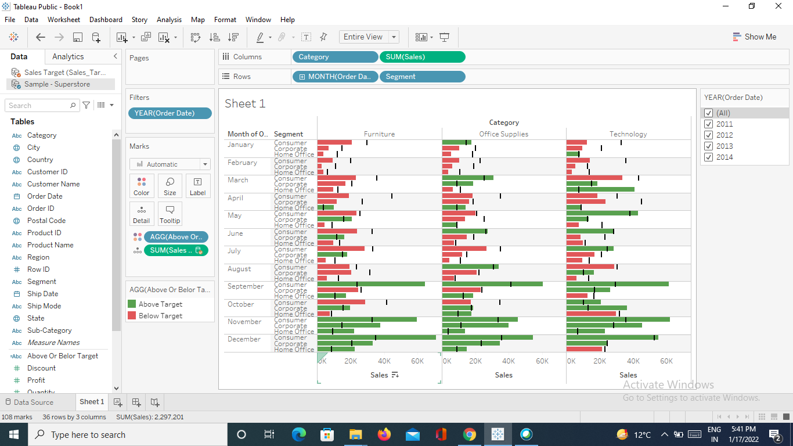

**ANALYSIS DRAWN FROM VISUALISATION**

* An analysis is made between target sales and actual sales for different segments of products and segment for different months and years
* From the visualization it is seen that for the month of November and December the actual sales was more than target sales for all three segments and categories
* For the month of September Consumer segment was able to meet target sales .
* In the month of January , febuary. March and april for furniture category sales target was not achieved by any segment
* In all it can be said that month of November and December were the only months when actual sales was much more than sales target .